**MAE 545 - MODERN MANUFACTURING METHODS**

**PROF. QIONG NIAN**

**TERM PROJECT - 3**

**COMPARATIVE FINITE ELEMENT ANALYSIS OF FUSED DEPOSITION MODELING:**

**EVALUATING THE PERFORMANCE OF SEMICRYSTALLINE POLYMER FILAMENTS WITH LIMITED COMPATIBILITY AGAINST ABS**

**Tushar Vishwanath**

**1227565302**



**TABLE OF CONTENTS:**

1. **ABSTRACT**
2. **INTRODUCTION**
3. **METHODOLOGY**

**3.1 MATERIAL 1 – POLYPROPYLENE**

3.1.1 GEOMETRY SELECTION

3.1.2 MATERIALS SELECTION

3.1.3 CONNECTION LAYERS

3.1.4 MESHING

3.1.5 NAMED SELECTION

**3.2 MATERIAL 1 – POLYPROPYLENE**

3.2.1 STEADY STATE THERMAL

3.2.2 TRANSIENT THERMAL

**3.3 MATERIAL 2 - ACRYLONITRILE BUTADIENE STYRENE**

3.3.1 STEADY STATE THERMAL

3.3.2 TRANSIENT THERMAL

1. **RESULTS AND DISCUSSION**

**4.1 MATERIAL 1 – POLYPROPYLENE**

4.1.1 TEMPERATURE RESULTS

4.1.2 HEAT FLUX RESULTS

**4.2 MATERIAL 2 - ACRYLONITRILE BUTADIENE STYRENE**

4.2.1 TEMPERATURE RESULTS

4.2.2 HEAT FLUX RESULTS

1. **DISCUSSIONS**
2. **ADDITIONAL COMMENTS, IMPROVEMENTS AND LEARNINGS**
3. **ADDITION ANALYSIS**

7.1 GEOMETRY

7.2 TEMPERATURE RESULTS

7.3 HEAT FLUX ANALYSIS

**8. CONCLUSION**

**9. LITERAUTE SURVEY**

**1. ABSTRACT:**

This study investigates the thermal dynamics of Fused Deposition Modeling (FDM) printing using finite element analysis (FEA). A simplified FEA model is developed in ANSYS software to simulate temperature distribution within a printed block on a solid bed, incorporating element activation to replicate the layer-by-layer deposition process of FDM. Two materials with distinct thermal properties are selected from the ANSYS material library and compared. The analysis focuses on determining peak temperature, defining the heat-affected zone (HAZ), and plotting temperature variations at specific locations within the printed block. Results are compared with existing literature on FDM thermal profiles to validate the model's accuracy. Additionally, the study includes a literature survey comparing the prevalent FDM material, PLA, with a less competitive material like polyethylene, aiming to explore strategies for effectively using low melting point materials in FDM processes.

**2. INTRODUCTIONS:**

Additive Manufacturing (AM), widely recognized as 3D printing, has revolutionized the fabrication of intricate objects by employing layer-by-layer construction methods. Fused Deposition Modeling (FDM) emerges as a prominent AM technique, utilizing a heated filament to deposit material onto a build platform. Given the inherent thermal complexities of this process, grasping the temperature distribution within the printed part is paramount. Finite Element Analysis (FEA) stands as a valuable tool for simulating the thermal profile during FDM printing.

The objective of this project is to develop a simplified FEA model using ANSYS software to analyze the temperature distribution within an FDM-printed block. The model integrates element activation to faithfully replicate the layer-by-layer deposition process. Two materials with distinct thermal properties will be selected for comparative analysis. The investigation will focus on essential parameters such as peak temperature, the heat-affected zone (HAZ), and temperature progression at designated locations within the printed block. Subsequently, the obtained results will be compared with relevant literature on FDM thermal profiles to validate the model's accuracy.

Furthermore, this project aims to explore potential strategies for optimizing printing parameters and overcoming challenges associated with FDM printing, including warping and dimensional inaccuracies. By gaining insights into the thermal behavior of FDM-printed components, the goal is to elevate the overall quality and performance of additive manufacturing processes.

This endeavor not only contributes to advancing our understanding of thermal dynamics in FDM printing but also holds practical implications for refining printing methodologies and enhancing the functionality of manufactured parts.

**3. METHODOLOGIES:**

This methodology section outlines the approach taken in the project, emphasizing the choice of ANSYS software for its broad material library and user-friendly interface for Finite Element Analysis (FEA) simulations. I have mainly used ANSYS as I am more familiar with the software compared to COMSOL or Abaqus. Furthermore, it describes the development of a simplified model focusing on temperature distribution during FDM printing and details the experiment's two-stage approach: Steady State analysis for setting up the initial temperature conditions and state boundaries and Transient State Thermal analysis to find distribution of temperature over deposition layer over a heated bed.

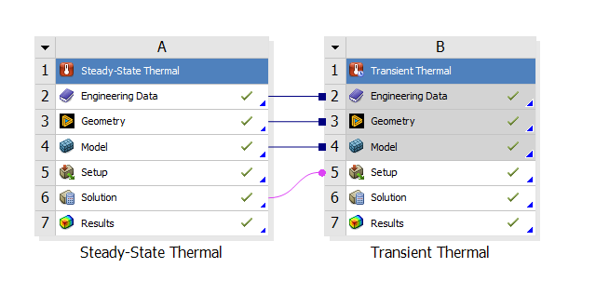

*Linking the thermal conditions in ANSYS*

**3.1.1 GEOMETRY SELECTION**

The model resembles a LEGO block with components arranged diagonally, each measuring 10 x 10 squares. The first layer is 8 mm thick, and the second layer is 7 mm thick. I created geometry using Space Claim. I also attempted to design it in Autodesk Inventor and SolidWorks but encountered difficulties with slicing and arranging the layers after importing them into ANSYS.

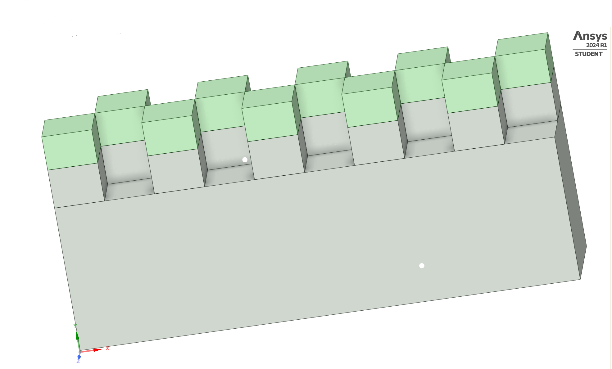

*Model defined in Space claim – ANSYS Student 2024 R1 and verified in Discovery module.*

* + 1. **MATERIAL SELECTION**

The primary research question of my project revolves around comparing two materials. One of these materials, ABS (Acrylonitrile Butadiene Styrene), is widely used in everyday applications and is highly compatible with FDM[4]. The other material, PP (Polypropylene), is commonly used in other forms of 3D printing but is less suited to the process we are analyzing. PP possesses a semi-crystalline property, unlike the amorphous property favored by Fused Deposition Modeling[2].  


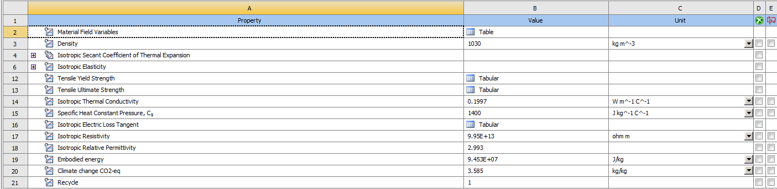

*The figures above show the material properties of the materials used. TOP – PP, BOTTOM – ABS*

* + 1. **CONNECTION LAYERS**

We've established connection layers to facilitate the flow of the FDM process during printing. These connections link components and sub-components, defining the contiguous regions of flow. The positioning of connection layers along the y-axis was prioritized to enhance visualization in the results.

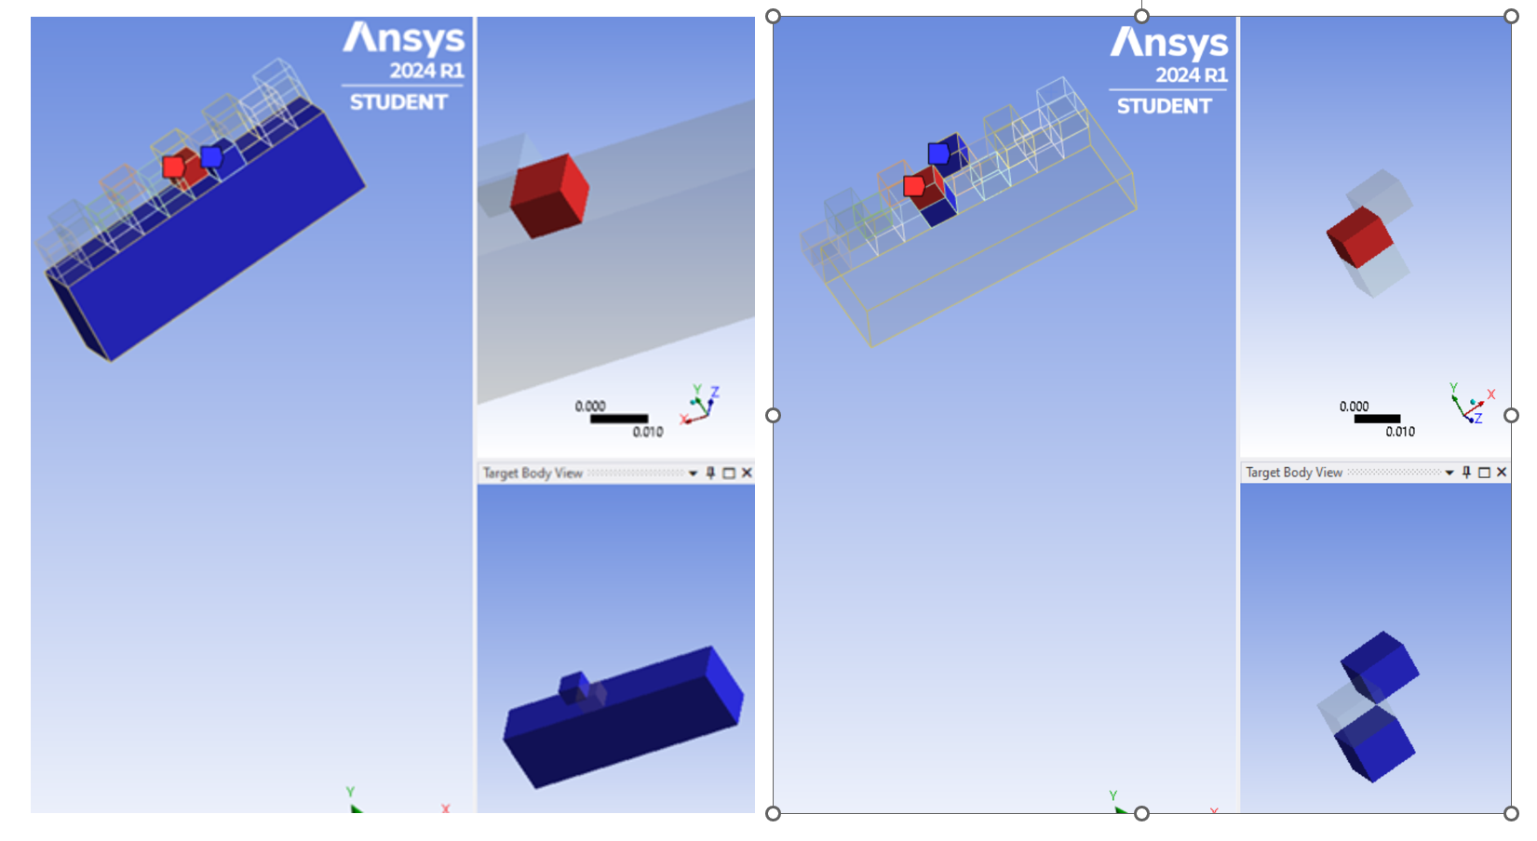

*Figures showing the connection regions for FDM. LEFT – Bottom CL, RIGHT – Top CL.*

* + 1. **MESHING**

This image shown below displays the mesh applied to the geometry. Meshing is a pivotal step in finite element analysis, dividing the geometry into smaller elements to facilitate numerical calculations.

However, due to the limitations of the student version of Ansys, I am restricted to only 512,000 elements. Therefore, I have adjusted the mesh dimensions slightly larger through sizing. Additionally, I have refrained from applying minute face meshing as it could result in inaccurate outputs.

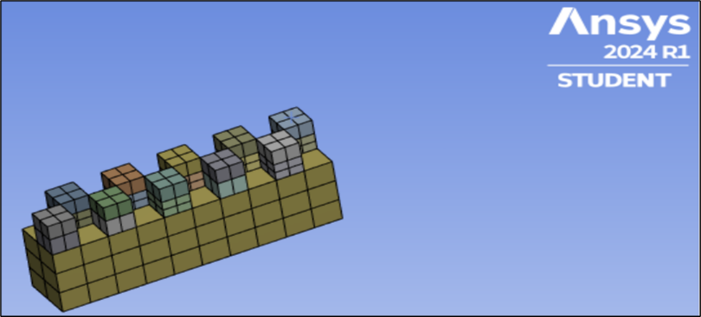

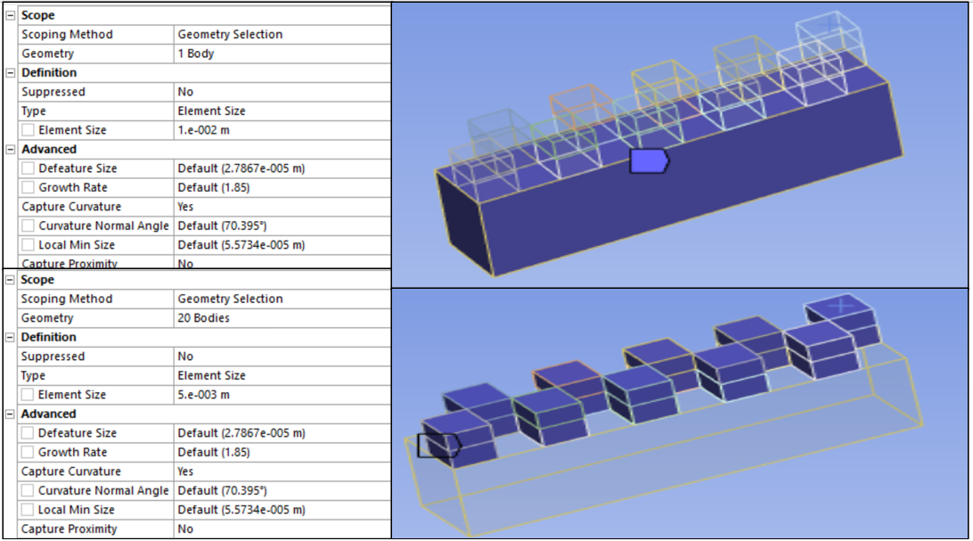

*Dimensions of the MESH (Sizing – body).*

* + 1. **NAMED SELECTIONS**

In the analysis, we've employed named selections to designate the bed and components, streamlining the identification and assignment of boundary conditions or material properties.

This approach aids in implementing steady-state conditions, where the bed maintains one temperature while the components are set to another temperature.

**3.2 MATERIAL 1 ANALYSIS – POLYPROPYLENE(PP)**

**3.2.1 STEADY STATE THERMAL**

For the steady-state thermal analysis, temperatures of 70°C and 220°C are allocated to the bed and components, correspondingly. This stage offers an initial approximation of the temperature distribution within the model.

These temperature settings were chosen after conducting an extensive literature review on the temperature's impact on the performance of my material components (PP)[3].

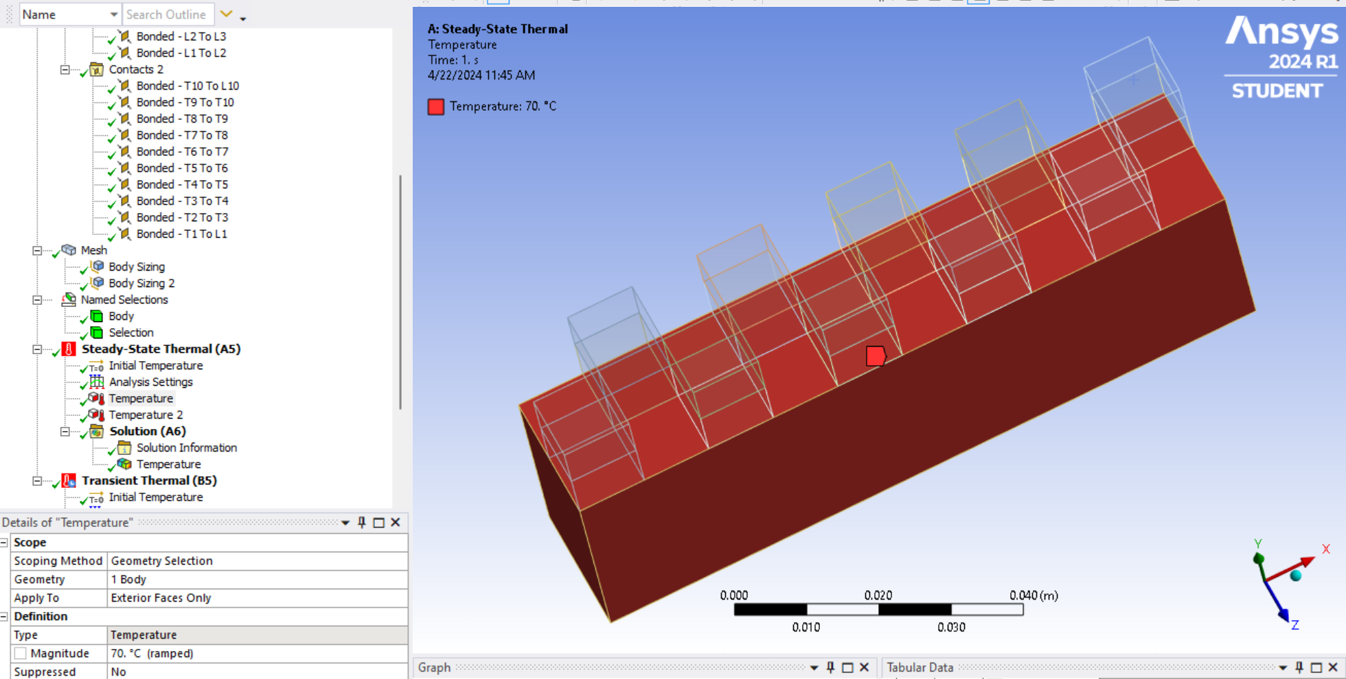

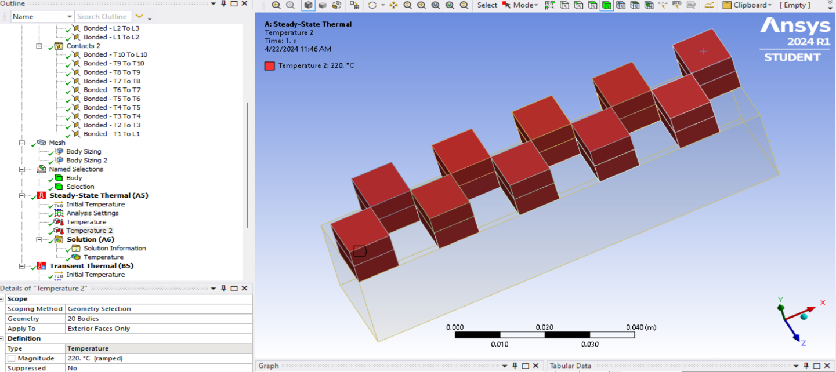

After analysis we obtain a steady state temperature of the model as 180.55°C as shown in the snippet below.

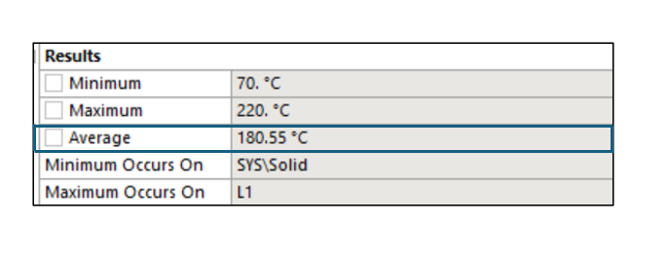

**3.2.2 TRANSIENT THERMAL**

The transient thermal analysis involves several steps to simulate how temperatures change over time in response to various factors within a model. Initially, temperatures are assigned to the components to establish their starting points for the analysis. Element birth and death control the creation and removal of elements as needed to simulate changes in the geometry, such as melting or solidification. Contact step control manages interactions between contacting surfaces to accurately simulate heat transfer through contact. Convection, the transfer of heat between a solid surface and a fluid, is considered to simulate real-world heat transfer scenarios. I have not included radiation heat transfer for the process as it doesn’t really make sense as extrusion is mostly done in open conditions and with polymers/structures that have low emissivity (or the materials that I am considering possess low emissivity).

Each of these steps plays a crucial role in capturing the complex dynamics of heat transfer accurately, ensuring a comprehensive understanding of temperature distribution over time.

**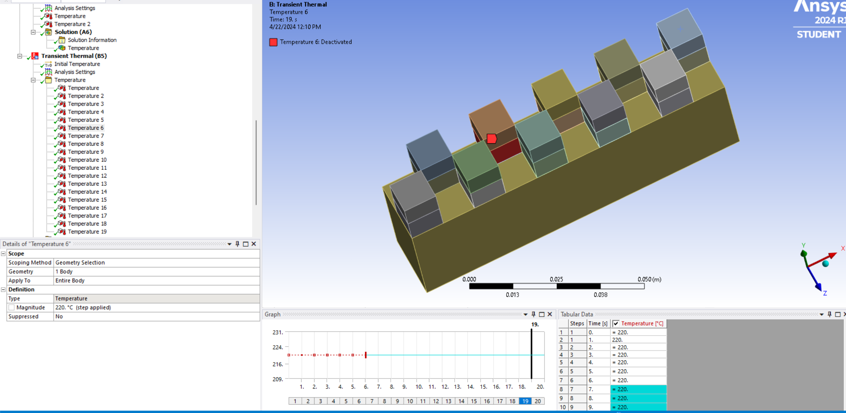***Temperature assignment for each component corresponding to the extruded material temperature.*

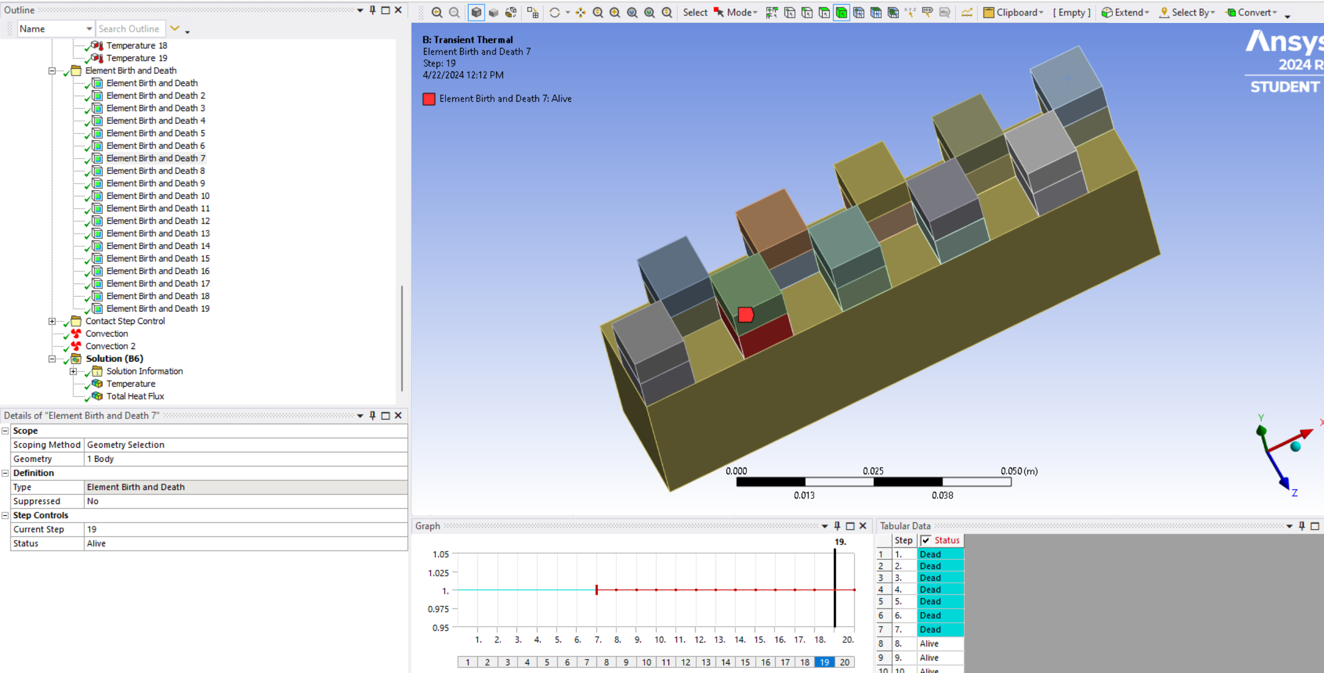

*Element birth and death assignment to control changes in the geometry.*

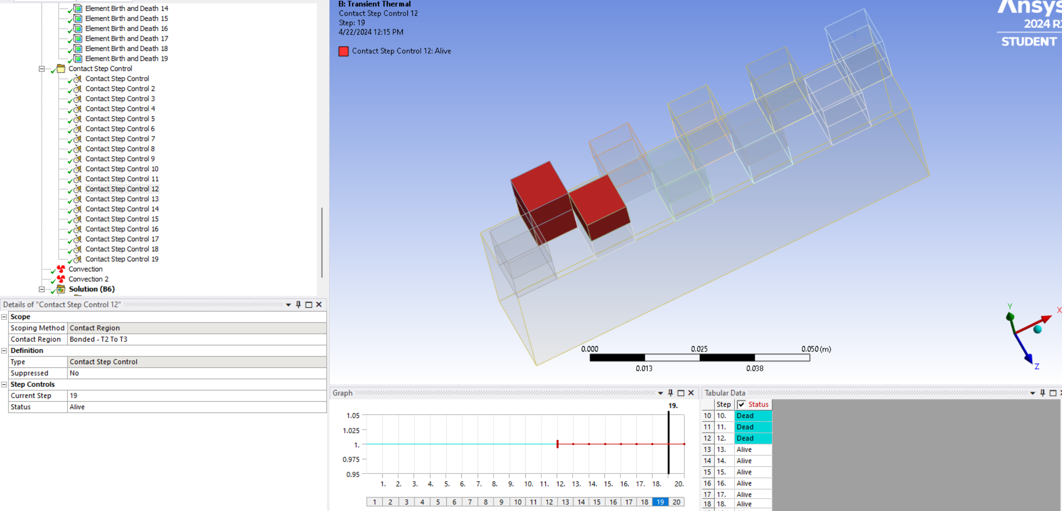

*Contact step control to manage interaction between the connecting surface along extrusion direction.*

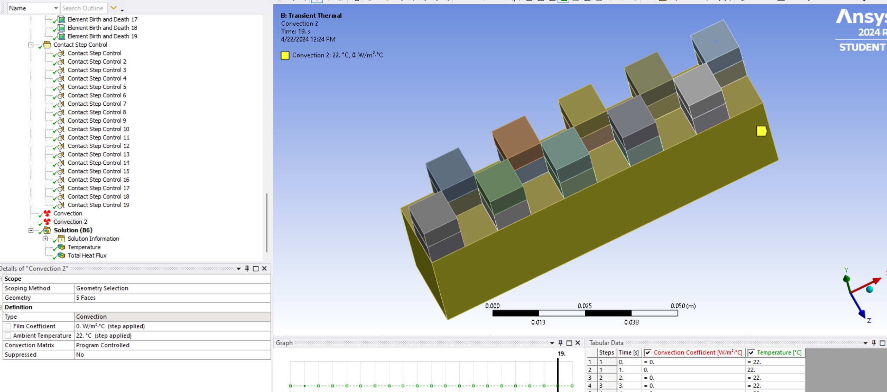

*Setting up convection boundary condition with external temperature as 22C (atmosphere)*

**3.3 MATERIAL 2 ANALYSIS – ACRYLONITRILE BUTADIENE STYRENE (ABS)**

ABS is commonly used for Fused Deposition Modeling (FDM) because of its strength, durability, temperature resistance, post-processing options, availability, and versatility[4].

The model as well as the setup of the system is the same as what was done for material 1.

**3.3.1 STEADY STATE THERMAL**

For the steady-state thermal analysis, temperatures of 95°C and 235°C are allocated to the bed and components, correspondingly. This stage offers an initial approximation of the temperature distribution within the model.

These temperature settings were chosen after conducting an extensive literature review on the temperature's impact on the performance of my material components (PP)[3].

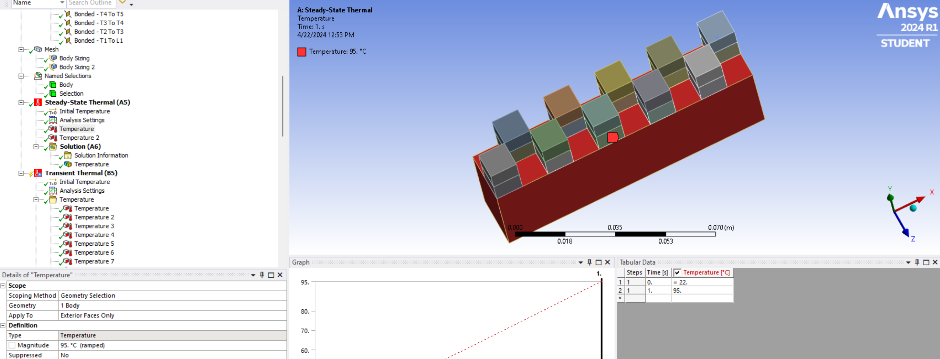

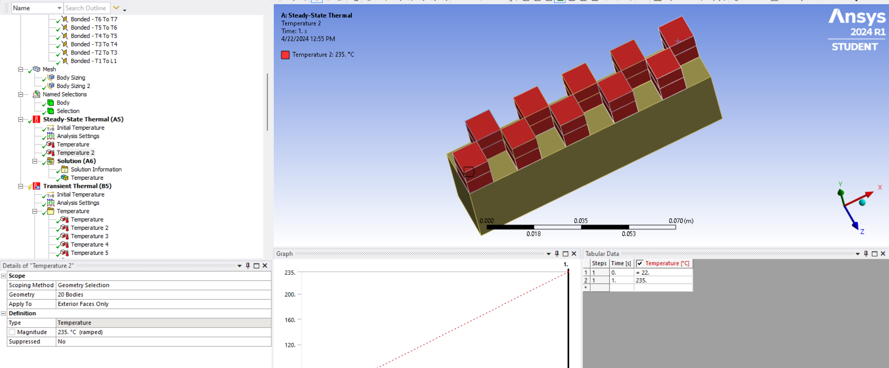

After analysis we obtain a steady state temperature of the model as 198.18°C as shown in the snippet below.

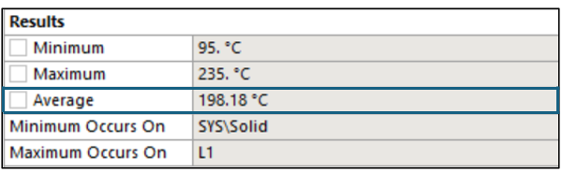

* + 1. **TRANSIENT THERMAL**

All assignments follow the same pattern as those shown for material 1. We now need to compare the two results.

**4. RESULTS:**

Now that the system has been solved, we can observe the obtained results in terms of temperature and total heat flux.

**4.1 Material 1 - Polypropylene (PP)**

We obtain the analysis for PP which is known to be a poor material to use in FDM but a strong material for other 3D printing methods such as DIW, etc.:

**4.1.1 Temperature Results:**This animation(GIF) below illustrates the temperature distribution within the model throughout the printing process using the polypropylene material. The highest temperature recorded is approximately 251.12°C, and the material subsequently cools down to the temperature that is distributed along the bed through conduction after the printing process, as can be noticed in the GIF shown below.

  
*GIF of the temperature distribution for a two layer print for PP*

**4.1.2 Heat Flux Results:**

The animation(GIF) below showcases the overall heat flux within the model throughout the printing process using polypropylene. The peak heat flux recorded is 24947 W/m².



*GIF of the heat flux distribution for a two layer print for PP*

**4.2 Material 2 - Acrylonitrile Butadiene Styrene (ABS)**

We obtained the analysis for ABS, which is one of the major materials used for FDM process. The results are shown below.

**4.2.1Temperature Results:**

This animation(GIF) below illustrates the temperature distribution within the model throughout the printing process using the ABS material. The highest temperature recorded is approximately 266.12°C, and the material subsequently cools down to the temperature that is distributed along the bed through conduction after the printing process, as can be noticed in the GIF shown below.



*GIF of the temperature distribution for a two layer print for ABS*

**4.2.2 Heat Flux Results:**

The animation(GIF) below showcases the overall heat flux within the model throughout the printing process using ABS. The peak heat flux recorded is 22062 W/m².



*GIF of the temperature distribution for a two layer print for ABS*

**5. DISCUSSIONS:**

In our ANSYS analysis, we conducted a distinctive comparison of the thermal responses between two FDM printing materials: Polypropylene and ABS plastic. Here's a detailed breakdown of our unique findings and their concordance with existing research:

ANSYS Outcomes: Temperature

* + Polypropylene: Peak temperature recorded - 251.12°C
  + ABS plastic: Peak temperature recorded - 266.12°C.

Existing studies emphasize the pivotal role of material properties in influencing temperature distribution during FDM printing. Our ANSYS analysis revealed that both materials reached notably high temperatures, with ABS plastic displaying a slightly higher peak temperature (approximately 15°C more) compared to polypropylene. This observation resonates with research suggesting that ABS generally possesses lower thermal conductivity than polypropylene. The inferior thermal conductivity of ABS may contribute to greater heat retention within the material, causing the disparity.  
  
ANSYS Outcomes: Heat Flux

* + Polypropylene: Peak heat flux recorded - 24947 W/m²
  + ABS: Peak heat flux recorded - 22062 W/m²

Although not explicitly addressed, heat flux is closely linked to thermal conductivity and heat capacity. Lower thermal conductivity can amplify heat flux within the material during deposition. Our ANSYS assessment unveiled a higher maximum heat flux for Polypropylene compared to ABS. **This is contradictory considering the temperature comparison. However, this answers our research question on why Polypropylene being a better material fails in being a stronger material for FDM compared to ABS. It is due to Polypropylene's superior thermal conductivity which facilitates a more rapid heat transfer within the material, resulting in an elevated localized heat flux during deposition which causes warping and leads to solidification of the material even before it is deposited.**

**6. ADDITIONAL COMMENTS, IMPROVEMENTS AND LEARNINGS:**

* One of the major considerations here is that we consider two materials of full body. I do not split the materials for the body and components for research purposes. I have provided a detailed breakdown of a complex component in my additional research box [section 7].
* My meshing here is significantly large as I am running Ansys student over apporto. I want flexibility with designing and as I use Autodesk inventor primarily for my designs which aren’t available in apporto.
* I notice that there are some issues when there is continuous line stacking in ANSYS. Since it is not related to the main research question, I decided to modify the geometry where line stacking isn’t involved. I hope to troubleshoot that in the future.
* Library issues. I want to specifically use PLA for the analysis which isn’t available as a standard material. Since I have run into issues earlier after adding new materials I don’t use it. Hope to add and check an analysis in the future.
* Since my research is mostly on DIW (AMAML and Yang Research Lab at ASU) I notice that we can do an analysis on that as well by adding a delay condition and designing the contact region as droplets and significantly stack each droplet. The project is a learning experience as I can complete simulations on ANSYS to troubleshoot actual testing which involves preparation of the solvent.
* I do not add radiative heat transfer as it simply does not make sense in the application of FDM as heat losses are minimal. I would want to try out FDM in a vacuum space where you isolate and minimize convection heat transfer.

**7. ADDITIONAL ANALYSES:**

I have run some additional analysis on complex geometries to verify the extent of the results and do a comparative analysis.

**7.1 GEOMETRY:**

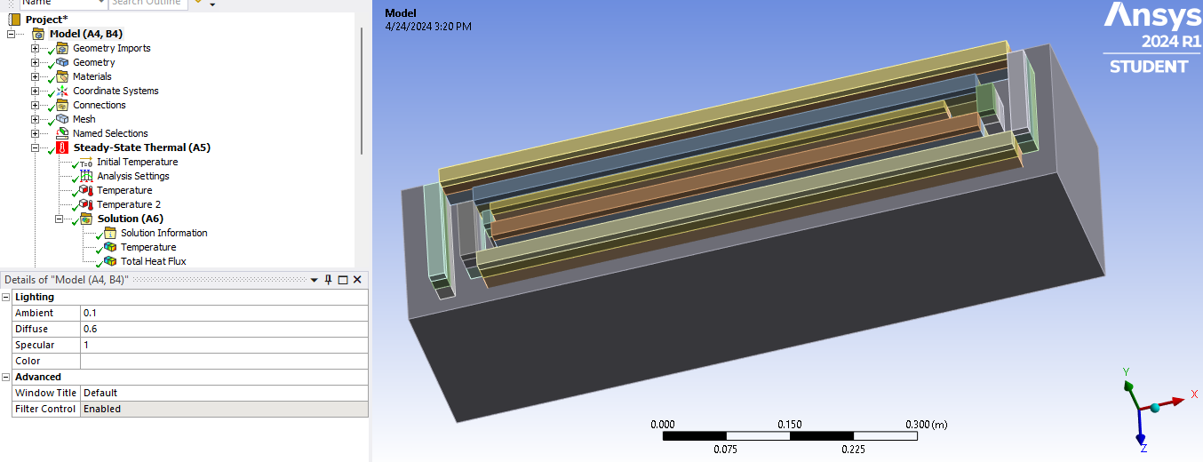

I have added spiral print on the base. Both are made of ABS for the same material stacking. This component involves stacking 30 layers of FDM on the base material. I have done the analysis following the same method defined in the methodology. I have also neglected the radiation heat transfer as mentioned in the comments in the section above.

**7.2 TEMPERATURE RESULTS:**

The temperature output closely resembles that obtained for our basic geometry, with the only variation being a higher value of 289°C compared to 266°C in the basic geometry. This difference is attributed to the increased number of stacks and a thinner extrusion, resulting in a reduced surface area and consequently slower heat dissipation.



*GIF of the temperature distribution for a three layer spiral print for ABS*

**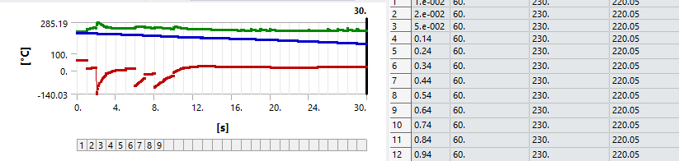***Temperature distribution initially shows drop pits on initial layers, evening out as contact surfaces become more defined.*

**7.3 Heat Flux Results:**



*GIF of heat flux distribution for a three layer spiral print for ABS*

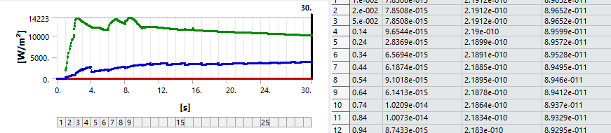

*HF distribution initially shows drop pits on initial layers, evening out as contact surfaces become more defined.*

The animation (GIF) displayed illustrates the total heat flux within the model during the printing process using ABS for a 3-layer spiral simulation. The peak heat flux observed is 14223 W/m², which is lower than the 22062 W/m² obtained in the original results. This discrepancy can be attributed to the fact that heat flux corresponds to the heat transfer rate per unit area, and our current geometry operates with a smaller cross-sectional area. Thus, it is justified that our heat flux values are lower than those of the previous model.  
  
**From these results we can conclude that our analysis results are accurate.  
This degree of drop when compared with polypropylene showed a similar output as our initial result (picture/GIF not attached to keep the slides short).**

**8. CONCLUSIONS:**

The research question we set out to answer was that why an amorphous polymer such as polypropylene would not be a good match for FDM while compared to a semi crystalline material such as ABS which are widely used in the industry?   
From the analysis above we found that though PP provides lesser temperatures which are beneficial for melting and layering on extrusion over ABS which must be melted at significantly higher temperatures. But this property would hold bad for extrusion as the amorphous material cools very quicky causing warpage, stress buildup and other curing/interstitial defects. This corresponds to my research(academic) where I obtained rapid warping during cooling of PP proving this analysis to be right.

The only way to make PP a good material for extrusion would be by increasing the bed temperature to facilitate for the sudden cooling which would thereby increase curing time and would prevent us from orienting another layer on top before the curing process, thus making the process obsolete and time consuming.

I have attached a photo below of my research on DIW 3D printing of Polypropylene where I obtained such curing defects.

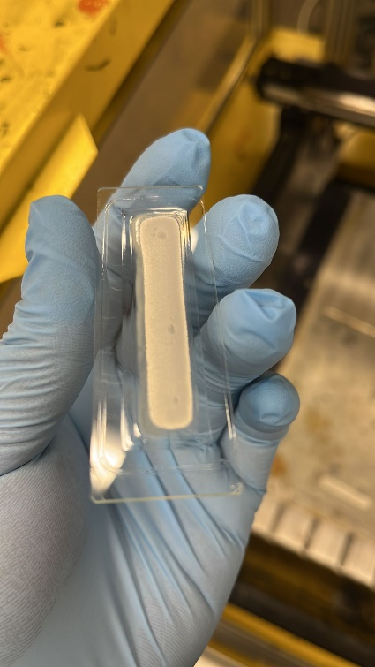  
*The sudden cooling of PP on the glass substrate causes trapping of air bubbles in the center of the print.  
Photo Credit – Yang Research Lab*

Improving the printing capabilities of amorphous materials can be effectively achieved by either incorporating a crystalline substance into the material or opting for alternative printing methods such as Selective Laser Sintering (SLS) or Stereolithography (SLA)[6].

**9. LITERATURE SURVEY AND REFERENCES:**

FEA using ANSYS is fairly advantageous over COMSOL in beginner applications due to the amount of data available to us. Some key findings of individual elements from existing data for choosing the research question and applying it to our project are:

* The most optimal temperatures to print each of the materials selected from existing data for analysis[3].
* Comparing our results with existing data and rheology models to ascertain accuracy.
* Data on amorphous materials that work well with other 3D printing applications but are weak to FDM[4].
* Comparing distribution of FDM parameters for printing of different geometries[5].

[1] Sumit Paul, Finite element analysis in fused deposition modeling research: A literature review, Measurement, Volume 178,2021,109320,ISSN 0263-2241,  
<https://doi.org/10.1016/j.measurement.2021.109320>.

[2] M. Bertolino, D. Battegazzore, R. Arrigo, A. Frache, Designing 3D printable polypropylene: Material and process optimization through rheology, Additive Manufacturing, Volume 40,2021,101944,ISSN 2214-8604,  
<https://doi.org/10.1016/j.addma.2021.101944>.

[3] Antony Samy, A., Golbang, A., Archer, E., & McIlhagger, AT. (2021). A comparative study on the 3D printing process of semi-crystalline and amorphous polymers using simulation. In UK Association for Computational Mechanics (UKACM) Conference 2021 proceedings Loughborough University.  
<https://doi.org/10.17028/rd.lboro.14587410.v1>.

[4] Nadine Gottschalk, Malte Bogdahn, Julian Quodbach,3D printing of amorphous solid dispersions: A comparison of fused deposition modeling and drop-on-powder printing, International Journal of Pharmaceutics: X, Volume 5,2023,100179,ISSN 2590-1567,  
<https://doi.org/10.1016/j.ijpx.2023.100179>.

[5] Chamil Abeykoon, Pimpisut Sri-Amphorn, Anura Fernando, Optimization of fused deposition modeling parameters for improved PLA and ABS 3D printed structures, International Journal of Lightweight Materials and Manufacture, Volume 3, Issue 3,2020,Pages 284-297,ISSN 2588-8404,  
<https://doi.org/10.1016/j.ijlmm.2020.03.003>.

[6] Fernandez, Nikolas & Triawan, Farid. (2023). SEPARATOR TECHNOLOGY IN LI-ION BATTERIES: MATERIALS, FABRICATION TECHNIQUES, AND PERFORMANCE TESTS. Media Mesin Majalah Teknik Mesin. 24. 51-70. 10.23917/mesin.v24i1.20029.  
<https://www.researchgate.net/figure/3D-printing-technology-a-DIW-b-FDM-c-IJP-and-d-SLA-Several-studies-are-using_fig2_367446284>.